The individual student work 3
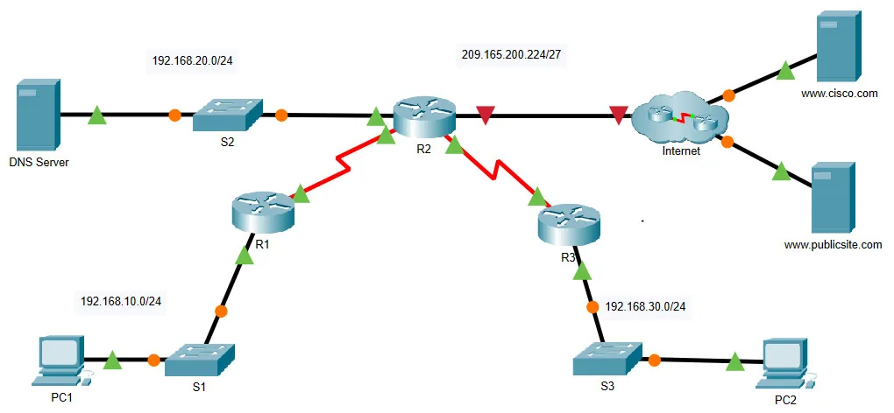
- Build the following topology
- Configure IP addresses and routing protocols
- Create the DHCP configuration
- Configure Access control lists and NAT

